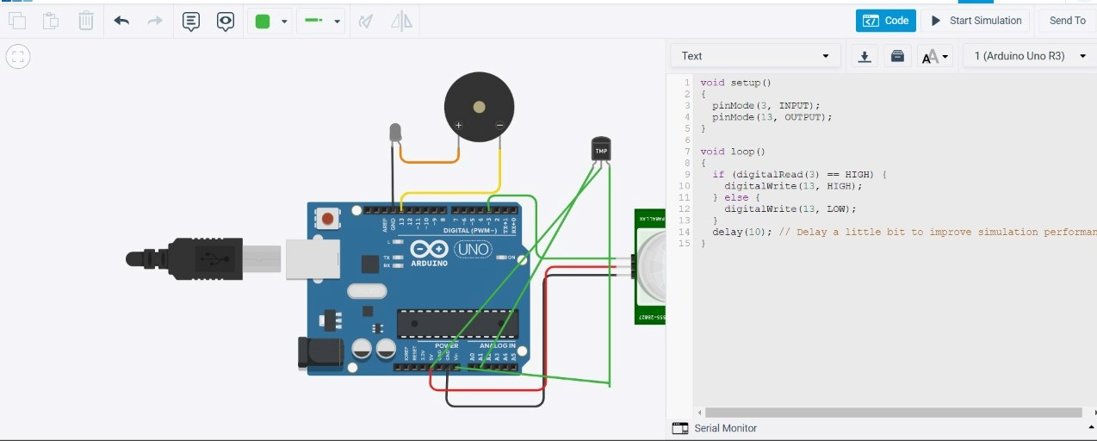

CODE:-

void setup()

{

pinMode(3,INPUT);

pinMode(13,OUTPUT);

}

void loop()

{

if(digitalRead(3)==HIGH)

{

digitalWrite(13,HIGH);

}

else

{

digitalWrite(13,LOW);

}

delay(10);

}